Behavior Consultants provide technical assistance, coaching, monitoring and professional development for all LEAs and schools participating in the PBIS initiative and for all students and staff members receiving and delivering PRC 29 services.
Northeast District 1: Osmond Lister (252) 338-1011 Ext 226 Southeast District 2: Lisa Taylor (252) 361-1004
North Central District 3: Rhonda Harrell (252) 299-3395 Sandhills District 4: Leslie Lowery (910) 544-8860
Piedmont-Triad District 5: Nancy Kueffer (919) 807-3596 Southwest District 6: Teri Putnam (704) 692-0177
Northwest District 7: Jennifer Phelps (828) 514-6332 Western District 8: Felicia Goodgoin (828) 702-5572
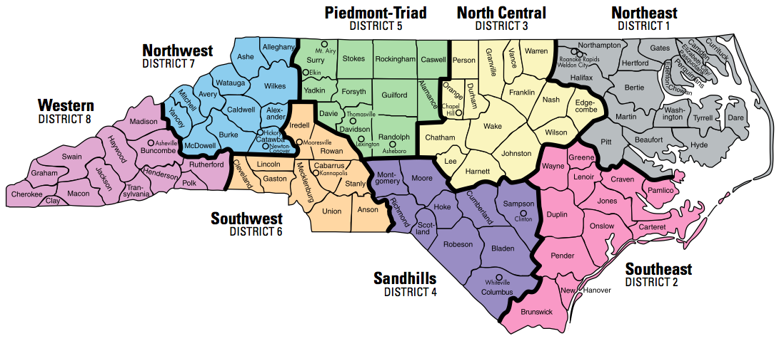
Section Chief, Joe Simmons (919) 807-3993 Statewide Consultant: Amanda Byrd (919) 807-3996

