System of Care Expansion

The Division of Mental Health, Developmental Disabilities, and Substance Abuse Services (DMHDDSAS) of the North Carolina Department of Health and Human Services (NC DHHS) was awarded a one-year grant in Federal Fiscal Year 2013 by the Substance Abuse and Mental Health Services Administration’s Center for Mental Health Services (SAMHSA – CMHS) to develop a coherent, comprehensive, and systematic strategic plan to improve and expand system of care services for children and youth with serious emotional disturbances (SED) and their families.

Demographic Characteristics of the NC General Populations
Females, at 51.3 percent, outnumber males in the general population estimate of the state for 2014. Whites, at 71.5 percent, constitute the majority population. Of the approximately 28 percent who belong to minority groups, Blacks or African Americans, at 22.1 percent, form the largest category with Asians coming next at 2.7 percent. American Indians are 1.6 percent of the general population. About 9 percent of the population is Hispanic or Latino. One out of ten North Carolinian households speaks a language other than English at home. A large majority (76.1%) of the resident households in which English is spoken “less than very well” is Latino or Hispanic followed by Asians and other Pacific Islanders (12.1%) and other Indo-Europeans (9%) (US Census, the 2012 Statistical Abstract). The percentage below poverty level (17.5%) is above the percentage for the whole county (15.4%). More than a third of the population is either currently serving or has served in the military or is a close relation. About 252,000 of North Carolinians 0-18 are uninsured (NC Institute of Medicine, 2012).

The Population of Focus
North Carolina served a total of 62,208 children and youth with serious mental illness in SFY 2012, a number that was almost evenly split between those aged 12 years and younger (51%) and those aged 12-17 years and older (49%); 11,036 were aged 18-20, half of who were female based on data collected by DMHDDSAS for the Mental Health Block Grant (URS tables 2012-2013). Data collected through the state’s web-based outcome data collection system, (NC Treatment and Outcomes Program Performance System) in 2013 showed that the most common psychiatric diagnoses for the younger age group were attention deficit/hyperactivity disorders (62.96%), disruptive disorders (12.74%), adjustment disorders (11.16%), anxiety disorders (5.97%), and conduct disorders (5.29%). Most common among youth 12-17 years of age were attention deficit/hyperactivity disorders (41.84%), conduct disorders (13.96%), depression (13.55%), disruptive disorders (8.21%), and bipolar disorders (7.75%).
Disparities
Children and youth in minority groups (with the exception of Asians and Pacific Islanders) are disproportionately served in the system, with the proportions of African Americans and American Indians about twice as those of the general population of North Carolinians younger than 18.

Males are likewise over-represented for all racial categories, the difference being largest among blacks or African Americans.
categories, the difference being largest among blacks or African Americans.

Diagnosis also varied by gender (with a higher percentage of females diagnosed for depression) and race (with a higher percentage of Blacks or African-Americans diagnosed with conduct disorders).

The System of Care Expansion Planning Grant
The planning grant that was awarded to the state in 2013 had, as its purpose, the development of a plan that was to respond to the unique needs of children with Serious Emotional Disturbances (SED) and their families in a way that recipients could understand, comprehensive in scope to address physical, emotional, behavioral health with services ranging from preventative to intensive residential care, and systematic in its use of strategies to implement goals and objectives. The grant, administered by the Division of Mental Health, Developmental Disabilities, and Substance Abuse Services, allowed for the hiring of a full-time SOC Expansion Planning Project Manager, who worked directly under the head of the Best Practices Team, who also functioned as Project Director of the SOC Expansion Planning Project. It also provided a substantial amount of funding to North Carolina Families United and Youth M.O.V.E. that enabled the organization to hire family and youth partners to ensure the participation of children and youth with SED and their families in the development of the plan.
Five Managed Care Organizations were selected as the pilot sites for the comprehensive strategic plan, based on their organizational readiness to implement System of Care. Shown below are the locations of the initial participating Managed Care Organizations: Cardinal Innovations, Eastpointe, Coastal Care, Centerpoint, and the single county MCO MeckLINK.
Local Management Entity - Managed Care Organizations (LME-MCOs) and 1915 b/c Medicaid Waiver Implementation Dates and System of Care Planning Collaborative Pilot Sites

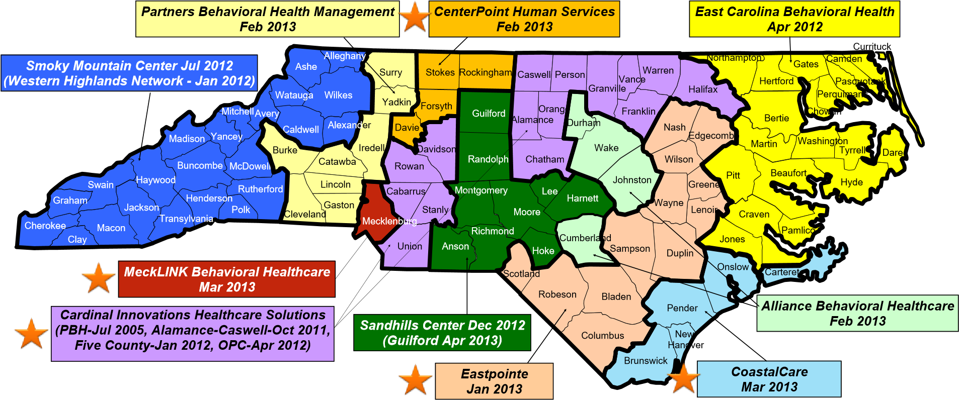

- Reflects LME-MCOs as of 2/27/14.
- Western Highlands Network operating under a management agreement 10/1/13, merger date 7/1/14.
- MeckLINK Behavioral Healthcare to become part of Cardinal Innovations 4/1/14.
System of Care Planning Collaborative Pilot Sites (5 LME-MCOs)
Planning Participants

The grant planning project drew on representatives from state, local, and non-profit agencies serving children and youth with SEDs and their families who had the obligation, motivation and capability for sustaining the plan that was to be developed. The Division of Mental Health, Developmental Disabilities, and Substance Services (DMHDDSAS) took the lead in the planning project that had the participation of permanent staff from all sections and teams of the Division led by the Section Chief of Community Policy and Management who was also the Principal Investigator of the planning project. NC Families United was identified as the lead family organization that would provide leadership, continued support and, most importantly, promote family and youth presence in the SOC Expansion Planning process. The NC Child, Youth, and Family Collaborative, an advisory body for the system of care grants in the state established since 2001, was an important collaborator in planning. Public state agencies (e.g. education, social work, juvenile justice, the state Medicaid agency), and community organizations participated in planning through their membership in the committees established to help in plan development.

The Planning Process
The development of the plan was characterized by an intensive collaboration among a wide div diversity of participants. Initially, the DMHDDSAS Internal Management Team was convened to provide the structure and management for the planning process. The state level SOC Expansion Steering Committee was then established. In order to carry out the deliverables of SOC Expansion Planning, the State-level SOC Expansion Steering Committee formed six sub-committees to strategically accomplish the identified goals and objectives.
Grant planning project staff and committees further engaged in the following activities:

- Convened the NC SOC Expansion Planning Advisory Board—composed of members from the NC State Collaborative for Youth, Children and Families—to meet monthly and provide valued advice from underserved populations to the state, systems and local level on how to improve SOC in relation to expansion planning.
- Assembled the NC Family Partner Cohort, which met quarterly to identify methods of increasing NC Family Partners and peer-support efforts in North Carolina’s managed care environment.
- Convened the NC SOC Breeze Meeting in a webinar designed for SOC Coordinators who work with North Carolina Managed Care Organizations (MCOs) to share concerns and advice to improve interagency collaboration across the state, systems and local level in relation to SOC expansion planning.
- Issued a competitive application process inviting local collaboratives across North Carolina to collectively or individually self-identify to serve as one of the five Planning Collaboratives (pilot sites) in conjunction with the SOC expansion planning process that resulted in the selection of sites identified for implementation.
- Convened the Eastern Carolina Mental Health Sustainability Council to address issues of SOC infrastructure, specifically at the regional level.
- Convened the NC SOC Expansion Planning Team (Steering Committee) to assemble every other month; six sub-committees were developed within the Steering Committee to convene at least once a month to address, target, and achieve the goals articulated in the grant application.
- Discussed appropriate levels of TA support with the NC SOC expansion planning process.
- Selected five regional Planning Collaboratives that worked in partnership with one another as well as with the SOC Expansion Planning Steering Committee and State Collaborative to collectively meet the deliverables for each goal and objectives articulated in the grant application; the six sites conducted baseline organizational readiness achievements.
- Convened the Community Action Sub-Committee within the SOC XP Steering Committee to reinforce communications and infrastructure as it pertains to advancing cultural linguistic competence with SOC expansion planning.
- Convened the Communications Sub-Committee within the SOC XP Steering Committee to reinforce communications and infrastructure as it pertains to advancing social marketing with SOC expansion planning.
- Convened the Governance Planning Sub-Committee within the SOC XP Steering Committee to reinforce communications and infrastructure as it pertains to ensuring sustainability with SOC expansion planning past the SOC XP grant.

The NC Child, Youth, and Family Collaborative served as a reliable forum to share updates on SOC Expansion strategies and continue to endorse SOC Expansion throughout North Carolina’s child serving system. The collaborative’s Cultural and Linguistically Competent Task Force organized a Youth Focus Group to obtain direct feedback from underserved populations on strategies to improve access to appropriate services.

