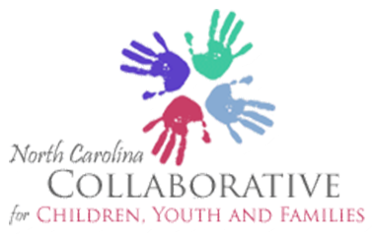

CELEBRATING SUCCESSES AND PLANNING FOR THE FUTURE!

The NC Collaborative for Children, Youth and Families Invites YOU to participate in our Annual Meeting

Goal: To celebrate our successes, deliver leadership training and provide an opportunity for new and seasoned members to support the activities of the committees of the collaborative

8:30-12:30 Leadership training, objectives:

1) Define leadership.
2) Identify the Competency Model definitions for Nonprofit leaders.
3) Use the framework of Social Styles to develop effective partnerships with agency staff, families and youth.
4) Practice giving and receiving effective, on-going feedback.
5) Develop an Individualized Leadership Plan that highlights current skills and determines pathways for improving abilities.

12:30-1:00 Networking lunch {will be provided by the collaborative) Carousel of committees of the collaborative objectives
1) To list the achievements of each of the committees
2) To choose short term or long-term tasks to support committees that interests you.
3) To suggest other activities that may assist local efforts for children, youth and families.

Date: December 14, 2017
Time: 8:30AM - 4:30PM
Location: Durham Human Services Building, 414 East Main Street, Durham, NC 27701

Registration IS REQUIRED. Please preregister no later than the close of business on December 12,
2017. To pre-register or for questions contact Renee Cordero at (336) 395 8828 (Mon-Thurs. 9am-4pm) or by email at corderorh@gmail.com

EVERY MEMBER IS ENCOURAGED TO INVITE ONE PERSON WHO MAY BE INTERESTED IN COLLABORATIVE ACIVITIES!

