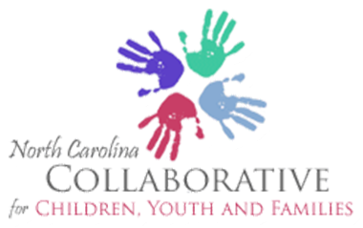

Meeting Calendar
January to December 2020

January 10th – Governor’s Institute
January 24th - Governor’s Institute
February 14th – Alliance Health (5200 Paramount Parkway, Morrisville, NC)
February 24th - Governor’s Institute
March 13th - Governor’s Institute
March 27th - Governor’s Institute
April 10th – No Meeting
April 24th - Governor’s Institute
May 8th - Governor’s Institute
May 22nd - Governor’s Institute
June 12th - Governor’s Institute
June 26th - Governor’s Institute
July 10th - Governor’s Institute
July 24th - Governor’s Institute
August 14th - Governor’s Institute
August 28th - Governor’s Institute
September 11th - Governor’s Institute
September 25th - Governor’s Institute
October 9th - Governor’s Institute
October 23rd - Governor’s Institute
November 13th - Governor’s Institute
November 27th – No Meeting
December - Strategic Meeting TBD

Vision: Children, youth and families are healthy, safe and successful at home, school and in their communities.

Mission: The North Carolina State Collaborative for Children, Youth and Families, through a SOC framework, provides a forum for collaboration, advocacy and action among families, public and private child serving agencies and community partners to improve outcomes for all children, youth and families.

Meeting Location: The Governor’s Institute
1121 Situs Court
Raleigh, NC
*Meetings occur at the above location unless notified of new location through our listserv.

