You are Invited
April 24th, 2020
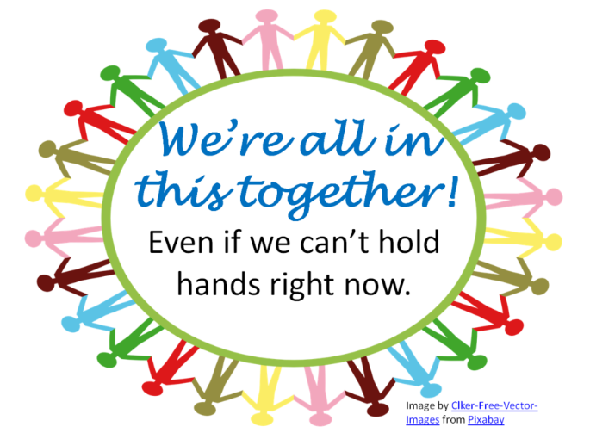
10:00am – 1:00pm
What do you know about Care Reviews?
What is Care
Review?

What is the effectiveness
of Care Reviews?

NC Collaborative for Children, Youth and Families wish to invite you to a very special state collaborative virtual meeting on April 24th. We will be discussing the state of Care Reviews in NC and if they are being implemented or still needed. At the meeting, we hope to hear everyone’s input and come to a decision about publishing a white paper on our thoughts about the Implementation of Care Reviews for Families and Youth. Please come with your thoughts. There will be time for an open conversation. Please invite all System of Care Coordinators, Family Partner Coordinators, Family Leads, Family and youth, providers…everyone. Your opinion is valued on this subject and greatly needed.

The virtual meeting information will be distributed closer to the date of the event.

For More information please feel free to visit our Facebook page @ NC Collaborative
or email: cbrown@ncfamiliesunited.org (Chandrika Brown, NC State Collaborative Family Co-Chair) or ABassMitchell@alliancehealthplan.org (Ashley Bass-Mitchell, NC State Collaborative Agency Co-Chair)
