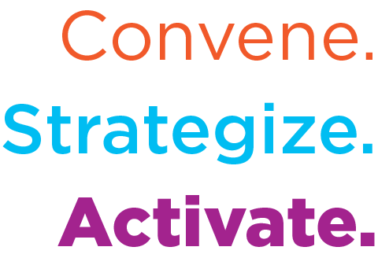
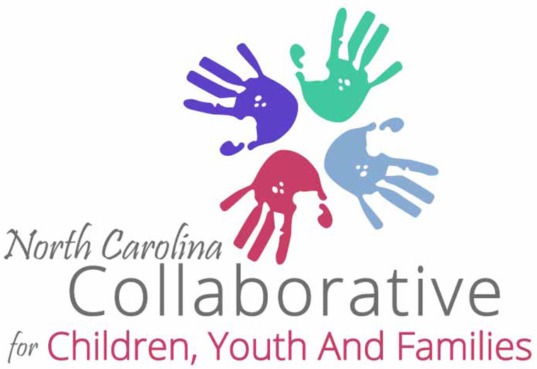

NCCCYF Monthly Legislative Update

NCCCYF Policy & Research Committee in partnership with i2i Center for Integrative Health provides this monthly legislative update. Please use and share widely to inform your community.

Email NCCYFmain@gmail.com to join the NCCYF mailing list.

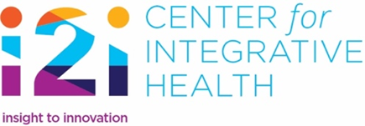 | To join i2i’s mailing list and receive our News Briefs and other information from i2i contact Jean@i2icenter.org, let her know you are with NCCCYF, ask to be added.
DATE: January 6, 2024
To access the NC General Assembly calendar use this link
Medicaid Changes Impacting Children, Youth and Families Continue in 2024

There were big changes to North Carolina’s Medicaid program in 2023 and the changes are guaranteed to continue in 2024. Perhaps the biggest win for North Carolina in 2023 was Medicaid expansion. When Medicaid expansion began on December 1, 2023, it brought the opportunity to increase access to health services for 600,000 North Carolinians. Expansion of Medicaid eligibility will directly benefit adults, but a 2017 study found that children are 29% more likely to have an annual well-child visit if their parents are enrolled in Medicaid. (Maya Venkataramani et al., “Spillover Effects of Adult Medicaid Expansions on Children’s Use of Preventive Services,” Pediatrics, December 2017, https://pediatrics.aappublications.org/content/140/6/e20170953)

At the same time that North Carolina moved forward with Medicaid expansion, the national Public Health Emergency to address the COVID-19 pandemic ended. The federal government terms it the “unwinding” because individuals were able to keep their Medicaid eligibility without going through a recertification process during the Public Health Emergency and they will now have to be recertified for eligibility. The recertifications are causing decreases in Medicaid enrollment across the country for both children and adults.

NC Data Available in Dashboards

The expansion and unwinding of Medicaid are closely tied together. NC Department of Health and Human Services has developed toolkits and programs for community partners to use in educating impacted individuals and families. One strategy NC DHHS has are dashboards that provide data for the public to know the progress in both expansion and unwinding. Here are the links to track the progress:
Medicaid Expansion Dashboard
Public Health Emergency Unwinding Dashboard

Federal Guidance on Unwinding of Children’s Enrollment

In December 2023, the federal government released new data and guidance around maintaining children’s enrollment in Medicaid (Note: In North Carolina, the Children’s Health Insurance Program or CHIP formerly known as Health Choice has been merged with Medicaid). To view the press release, use this link. Included in the release are slides with key strategies to maintain children’s enrollment that include:

• Adopt every possible 1902(e)(14)(A) strategy available, particularly those that improve rates of Medicaid auto-renewal, using data from Supplemental Nutrition Assistance Program (SNAP), Temporary Assistance for Needy Families (TANF), or other means-tested benefit programs.
• Ensure that a child’s eligibility is being considered separately from their family’s eligibility to ensure that eligible children remain enrolled even if their head of household is no longer eligible.
• If a child is found ineligible for either Medicaid or CHIP, use data obtained in the original auto-renewal process to make the eligibility determination for the other program to ensure a smooth transition and continuous coverage (e.g., automatically transitioning children’s coverage to CHIP would dramatically reduce barriers and improve children’s coverage).
• Remove barriers to enrollment in CHIP, including enrollment fees, premiums, and waiting periods.
• Implement Express Lane Eligibility (ELE) for children by using School Lunch programs, Head Start, and the Women, Infant, and Children's program (WIC) and other sources to streamline and simplify the application and renewal process for children to increase auto-renewals.
• Expand Medicaid to help support health coverage for youth aged 19-23. Partner with other child-and family-facing state agencies, schools, and community-based organizations. Ensure that all state agencies that interact with children and families know where to find communications about redetermination.
• Ask sister agencies that serve a large volume of Medicaid and CHIP enrollees to remind workers across the agency to ask families about their redetermination and to provide support if they need it.
• Partner with State and local education agencies and schools to reach families.
• Hire staff at call centers who speak the most common non-English languages in your state.
• Increase call center capacity to drive down call center wait times and abandonment rates.
• Provide data to health plans, community health centers, and pediatric practices to help them provide direct support to families renewing coverage.

Impending Changes to Medicaid and the Public BH/IDD System

North Carolina has other changes in the Medicaid program that are expected in 2024. They include:
- Request for Proposals for the Children and Families Specialty Plan, award of the contract and implementation planning
- Implementation of the BH/IDD Tailored Plan in four LME/MCOs
- Ramp up of new programming with approximately $800 million appropriated by the 2023 NC General Assembly
What Does this Mean for Advocates? An Editorial Note by Ann Rodriguez

In the past, I have used the word “opportunity” when policy changes are occurring. Policy shifts can bring discussion and identification of challenges and resolutions. All of these create opportunity to strengthen systems and partnerships. If I had to choose a word for 2024, it would be “necessity”. The involvement of children, youth and families will be a necessity for these changes to result in strengthening the system. Some strategies for advocates that come to mind include:
- Determine what is important to you in these policy shifts.
- Find the venues in which the policy discussions are occurring.
- Use resources to educate yourself on the policy issues and ask questions to better understand issues.
- Convey your views because you have expertise and valued views!
The Transition to Four LME/MCOs and to BH/IDD Tailored Plans
The 2023 Appropriations Act included provisions that gave the NC DHHS Secretary more authority to consolidate and merge Local Management Entity/Managed Care Organizations (LME/MCOs). For more information on these provisions, begin at page 256 of the 2023 Appropriations Act. On November 1, 2023, NC DHHS Secretary Kinsley directed the dissolution of the Sandhills Center LME/MCO and the consolidation of the Eastpointe and Trillium LME/MCOs. Only three of Sandhills counties will not be a part of the Eastpointe and Trillium consolidation. Davidson County will be served by Partners Health Management, Harnett County will be served by Alliance Health, and Rockingham County will be served by Vaya Health. All other counties of Sandhills will be included in the consolidation of Eastpointe and Trillium. NC DHHS has developed a Frequently Asked Questions (FAQ) document that provides the basic information. The consolidation of Eastpointe and Trillium will occur on February 1, 2024 with Trillium named as the surviving entity until a rebranding occurs by January 2025. Trillium is hosting weekly member and family office hours and daily provider office hours to answer questions as part of the consolidation of Trillium, Eastpointe and Sandhills Center.
Members and Family Office Hours
Date: Every Monday through Feb. 16, 2024
Time: 4:00-4:30 p.m.
Join Link: Join here
Providers Office Hours
Date: Daily through Feb. 16, 2024
Time: 12:00-12:30 p.m.
Join Link: Join here

State CFAC Panel Discussion with LME/MCO CEOs

The State Consumer and Family Advisory Committee (State CFAC) is holding “The Future State of Care” meeting on Wednesday, January 10, 2024 at the Alliance Health office in Morrisville and a virtual option is also available. The meeting will be from 12:30 pm – 3 pm and will include a panel of the LME/MCO Chief Executive Officers.

Opportunity for Input! Community Needs Assessment Survey

The following email was recently sent out to stakeholders:
Dear NC Mental Health/Behavioral Health System (MH/BH) Stakeholder,

The Community Needs Assessment (click to access survey) is designed to assist mental health stakeholders in determining the current strengths and service gaps in the mental health system. The information obtained from the Community Needs Assessment will illuminate for stakeholders what needs to be addressed in North Carolina in order to transform and create recovery-oriented mental health services and systems.

As part of the new NC System of Care – High Fidelity Wraparound Expansion Grant from SAMHSA, this survey will be administered to MH/BH stakeholders statewide once a year for the next four years. It is our hope that our work throughout and beyond the grant period will bring about positive change that is reflected in your responses to this survey over these years.

If you can find approximately 20 minutes to share your experience and viewpoint on NC’s MH/BH System, you will be giving a tremendously valuable gift to young people in our state: the gift of sharing your viewpoint from your unique place in our system. This survey will close on January 12th. Upon the close of the survey, a raffle for $50 gift cards (provided by non-state and federal funds) will be awarded to 10 individuals who completed the survey. Please feel free to share the link to this survey widely with anyone who has a stake in NC’s MH/BH system.

Resources:

Child Transformation Resource Center through the Center for Healthcare Strategies

Legislative Analysis of 2023 NC Child Welfare Legislative Changes by UNC-CH School of Government by Sara DePasquale, Associate Professor of Public Law and Government

Mental Health Legislative Breakfast will be held on February 3, 2024. This breakfast is open to anyone (does include a registration fee and offers scholarships) and is an opportunity to hear from key legislative and policy leaders in the State and to network with other advocates. Registration opens on December 1. You can follow their website for more information as it is posted.

Bills Filed and Still Active for 2024 Short Session:
H. 23, Education Studies and Other Changes, passed House, referred to Senate Education/Higher Education
H. 26, Education Omnibus, passed House, referred to Senate Education/Higher Education
H. 142, Protect our Students Act – Agency Bill, passed House, reported favorably by Senate Committees—Judiciary, Education/Higher Education, and Pensions and Retirement and Aging, sent to Senate Rules
H. 145, Social Services Reform, passed House
H. 150, School Contracted Health Services, passed House
H. 186, Division of Juvenile Justice Modifications – Agency Bill, passed House
H. 187, Equality in Education, passed House
H. 188, Standards of Student Conduct, passed House
H. 253, Prevent Students from Harm Act, passed House
H. 382, Registered Nurses in Schools, passed House
H. 478, Support Students with Disabilities Act, referred to House Appropriations
H. 500, NCCWTC/Medicaid Related Recs., passed House
H. 647, Expedite Child Permanency, passed House
H. 748, Felony Child Abuse/Expand Scope, passed House
S. 406/H. 823, Choose your School, Choose your Future, H. 823 passed House S. 406 reported favorably by Senate Education, re-referred to Senate Appropriations
H. 823, Choose your School, Choose your Future, passed House
H. 855, Strengthening Care for Children and Families, referred to House Health then House Appropriations
H. 858, Fonda Bryant Suicide Prevention Signage Act, referred to House Appropriations
H. 860, Protect Our Youth in Foster Care, referred to Health House
H. 862, Strengthen Child Fatality Prevention System, reported favorably by House Health and re-referred to House Appropriations
H. 863, Foster Care Reform/Funds, referred to House Appropriations
H. 887, Enhance Local Response/Mental Health Crises, referred to House Rules

S. 303, Strengthen Juvenile Laws, passed Senate
S. 425, Medicaid Omnibus – Agency Bill, passed Senate, referred to House Health
S. 493, Go Big for Early Childhood Education, referred to Senate Appropriations
S. 567, School Mental Health Support Act
S. 598, Healthy Students – A Nurse in Every School, referred to Senate Appropriations
S. 625, Child Welfare, Safety and Permanence Reforms, passed Senate, referred to House Judiciary 2
H. 405/S. 694, Funds for Ready for School, Ready for Life, H. 405 referred to House Appropriations, S. 694 referred to Senate Appropriations
H. 705/S. 713, Build Safer Communities and Schools Act, both House and Senate bills referred to Rules
S. 740, Fully Fund School Psychologists and Counselors, referred to Senate Appropriations

New Laws:
S. 115, SL2023-3, Repurpose RJ Blackley Center as Psych Hospital
H. 76, SL2023-7, Access to Healthcare Options
S. 20, SL2023-14, Care for Women, Children and Families Act
H. 190, SL2023–65, Dept. of Health and Human Services Revisions – Agency Bill
H. 605, SL2023-78, School Threat Assessment Teams
H. 815, SL2023 – 82, The Loving Homes Act
H. 674, SL2023-96, Child Advocacy Centers/Share Information
S. 49, SL2023-106, Parents Bill of Rights
H. 186, SL2023-114, Juvenile Justice Modifications
H. 259, SL2023-134, 2023 Appropriations Act
H. 361, SL2023-135, Require Report/Protection & Advocacy Agency

