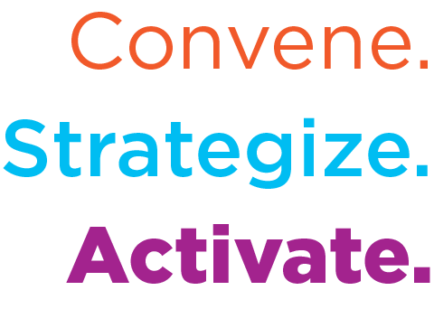
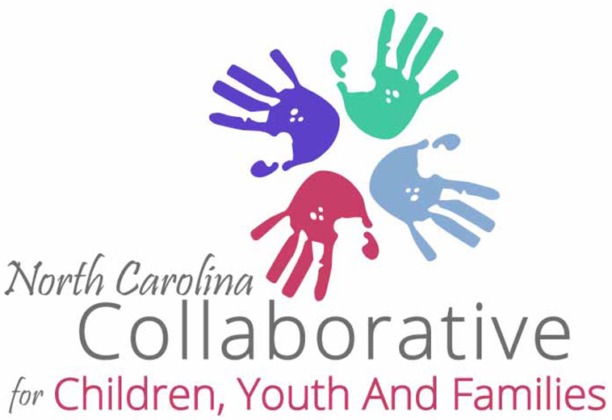

NCCCYF Monthly Legislative Update

NCCCYF Policy & Research Committee in partnership with i2i Center for Integrative Health provides this monthly legislative update. Please use and share widely to inform your community.

Email NCCYFmain@gmail.com to join the NCCYF mailing list.

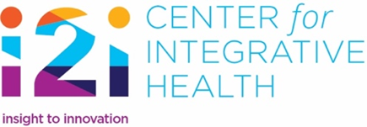 | To join i2i’s mailing list and receive our News Briefs and other information from i2i contact Jean@i2icenter.org, let her know you are with NCCCYF, ask to be added.
DATE: February 9, 2024
To access the NC General Assembly calendar use this link
February is Family Support Awareness Month!
(Click on link for proclamation and toolkit)
NC Medicaid Expansion Effort Gets Boost From the Federal Marketplace

NC Department of Health and Human Services (DHHS) has created the “Spread the Word” campaign knowing that getting information to individuals who have not been involved with Medicaid in the past, but now may be Medicaid eligible through expansion, is a heavy lift. The federal government, through healthcare.gov (also known as the Marketplace), is providing assistance to North Carolina by sending over 500,000 letters out to North Carolinians who have health insurance through the marketplace and may be eligible for Medicaid through expansion. In addition, individuals may apply for NC Medicaid through healthcare.gov, without having to go through the local department of social services.

Parent Bill of Rights Challenged

A Title IX complaint has been filed with the federal government by the Campaign for Southern Equality against the NC State Board of Education and NC Department of Public Instruction alleging that the new North Carolina Parent Bill of Rights is resulting in “systemic marginalization of LGBTQ+ students” (citation: Asheville Times, February 6, 2024 article). According to the US Department of Justice, “Congress enacted Title IX with two principal objectives in mind: to avoid the use of federal resources to support discriminatory practices in education programs, and to provide individual citizens effective protection against those practices. See Cannon v. University of Chicago, 441 U.S. 677, 704 (1979).” (citation: US DOJ, Civil Rights Division, Title IX Legal Manual)

Federal Focus on School-Based Health Services

The federal Centers for Medicare and Medicaid Services (CMS) announced that they have $50 million in grants to States to deliver critical school-based health services to children. The grants will be provided to 20 states to receive up to $2.5 million in funding that can help states implement, enhance, and expand the use of school-based health services through Medicaid for children who are Medicaid eligible (including children who were formerly with Health Choice). North Carolina is one of 16 states that offer school-based health services that go beyond the Individualized Education Plan (IEP). The federal government hopes to encourage more states to offer these services through this funding and is building on the work done through Project Aware. With the move in North Carolina Medicaid to integrated care, school-based health services are an opportunity to address the needs of school-age children and their families. States must apply for the grants by March 25th. CMS press release

Resources

- The NC Division of MH/DD/SUS Side-by-Side Webinar on March 4, 2024, 2-3 pm, will be focused on Child Behavioral Health. To register, use this link.
- The Children and Families Specialty Plan paper was updated. This is in anticipation of the Request for Proposals being released that will begin the contract process.
- NC Department of Public Instruction reported that there has been a decrease in dropouts from school and an increase in school incidents. The January 31, 2024 press release provides information about the next steps for DPI and the Center for Safer Schools in supporting schools to address school incidents.
- The Joint Legislative Oversight Committees on Health and Human Services and on Medicaid met on February 6. To access the presentations from those meetings, use these links:
  - Joint Legislative Oversight Committee on Health and Human Services
  - Joint Legislative Oversight Committee on Medicaid
The Committees will meet again on March 12th.

2024 Legislative Session Begins in late April!
Bills Filed and Still Active for 2024 Short Session:
H. 23, Education Studies and Other Changes, passed House, referred to Senate Education/Higher Education
H. 26, Education Omnibus, passed House, referred to Senate Education/Higher Education
H. 142, Protect our Students Act – Agency Bill, passed House, reported favorably by Senate Committees—Judiciary, Education/Higher Education, and Pensions and Retirement and Aging, sent to Senate Rules
H. 145, Social Services Reform, passed House
H. 150, School Contracted Health Services, passed House
H. 186, Division of Juvenile Justice Modifications – Agency Bill, passed House
H. 187, Equality in Education, passed House
H. 188, Standards of Student Conduct, passed House
H. 253, Prevent Students from Harm Act, passed House
H. 382, Registered Nurses in Schools, passed House
H. 478, Support Students with Disabilities Act, referred to House Appropriations
H. 500, NCCWTC/Medicaid Related Recs., passed House
H. 647, Expedite Child Permanency, passed House
H. 748, Felony Child Abuse/Expand Scope, passed House
S. 406/H. 823, Choose your School, Choose your Future, H. 823 passed House S. 406 reported favorably by Senate Education, re-referred to Senate Appropriations
H. 823, Choose your School, Choose your Future, passed House
H. 855, Strengthening Care for Children and Families, referred to House Health then House Appropriations
H. 858, Fonda Bryant Suicide Prevention Signage Act, referred to House Appropriations
H. 860, Protect Our Youth in Foster Care, referred to Health House
H. 862, Strengthen Child Fatality Prevention System, reported favorably by House Health and re-referred to House Appropriations
H. 863, Foster Care Reform/Funds, referred to House Appropriations
H. 887, Enhance Local Response/Mental Health Crises, referred to House Rules

S. 303, Strengthen Juvenile Laws, passed Senate
S. 425, Medicaid Omnibus – Agency Bill, passed Senate, referred to House Health
S. 493, Go Big for Early Childhood Education, referred to Senate Appropriations
S. 567, School Mental Health Support Act
S. 598, Healthy Students – A Nurse in Every School, referred to Senate Appropriations
S. 625, Child Welfare, Safety and Permanence Reforms, passed Senate, referred to House Judiciary 2
H. 405/S. 694, Funds for Ready for School, Ready for Life, H. 405 referred to House Appropriations, S. 694 referred to Senate Appropriations
H. 705/S. 713, Build Safer Communities and Schools Act, both House and Senate bills referred to Rules
S. 740, Fully Fund School Psychologists and Counselors, referred to Senate Appropriations

New Laws:
S. 115, SL2023-3, Repurpose RJ Blackley Center as Psych Hospital
H. 76, SL2023-7, Access to Healthcare Options
S. 20, SL2023-14, Care for Women, Children and Families Act
H. 190, SL2023–65, Dept. of Health and Human Services Revisions – Agency Bill
H. 605, SL2023-78, School Threat Assessment Teams
H. 815, SL2023 – 82, The Loving Homes Act
H. 674, SL2023-96, Child Advocacy Centers/Share Information
S. 49, SL2023-106, Parents Bill of Rights
H. 186, SL2023-114, Juvenile Justice Modifications
H. 259, SL2023-134, 2023 Appropriations Act
H. 361, SL2023-135, Require Report/Protection & Advocacy Agency

