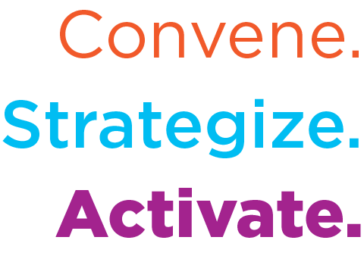
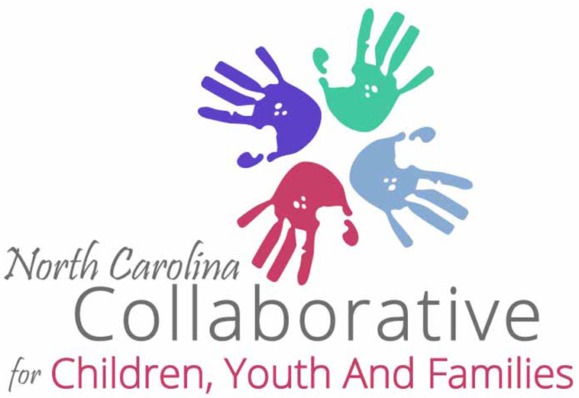

NCCCYF Monthly Legislative Update

NCCCYF Policy & Research Committee in partnership with i2i Center for Integrative Health provides this monthly legislative update. Please use and share widely to inform your community.

Email NCCYFmain@gmail.com to join the NCCYF mailing list.

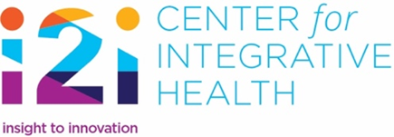 | To join i2i’s mailing list and receive our News Briefs and other information from i2i contact Jean@i2icenter.org, let her know you are with NCCCYF, ask to be added.
DATE: March 3, 2024
To access the NC General Assembly calendar use this link
Upcoming Legislative Meetings
March 12, 2024:
9 am Joint Legislative Committee on Health and Human Services, 643 Legislative Office Building, Livestream at this link. To get handouts, use this link.
1 pm Joint Legislative Committee on Medicaid, 643 Legislative Office Building, Livestream at this link. To get handouts, use this link.
NOTE: Joint legislative committees meet during the time BETWEEN sessions to get updates on pertinent issues and formulate recommended legislation for the impending session.

NC DHHS Begins Community Engagement Initiatives with Cross-Division Focus
NC DHHS Community Partner Engagement Plan
NC Department of Health and Human Services Secretary, Kody Kinsley, issued a Secretarial Directive (005) that NC DHHS will begin a Community Partner Engagement Plan. A website has been launched that include the directive, the Plan, a video from Secretary Kinsley and other information at this link. Essentially, the purpose of the Plan is to achieve equitable health outcomes for North Carolinians and to acknowledge that this can only be achieved with “active community involvement”. The website further defines active community involvement as “Involving people from communities served, people who have experienced health issues or lived experiences in making policy decisions.”
The website includes a roster of organizations, committees, councils, etc. along with information about the group and a NC DHHS contact. The roster includes the NC Collaborative for Children, Youth and Families as well as the System of Care Collaborative.

There is also a Community and Partner Engagement Guide that is framed using a Health Equity Framework that includes five pillars: 1) community at the center; 2) changes to policies, systems and environment that addresses the root causes of health inequity; 3) leveraging data-driven strategies to support decision-making; 4) catalyze multi-sector collaboration; 5) building sustainability and organizational capacity. NOTE THE SOC INTERSECTION: System of Care (SOC) Principles/Core Values: 1) Family-Drive and Youth Guided; 2) Interagency Collaboration; 3) Data Driven and Accountability; 4) Individualized and Strength-based; 5) Home and Community-Based Services with trauma-informed care and evidence-based practices.

The Secretarial Directive went out to all NC DHHS staff to articulate responsibilities of NC DHHS leaders and staff in carrying out the components of the Community Partner Engagement Plan.

Child Behavioral Health Advisory Committee Established

NC DHHS is creating a Child Behavioral Health Advisory Committee. Five of the NC DHHS Divisions will coordinate to support the discussions of the Committee and that includes the following Divisions: Mental Health/Intellectual-Developmental Disabilities/Substance Use Services; Social Services, Child and Family Well-Being; Health Services Regulation, and Health Benefits. The Committee will consist of professional members, community partners and family members with lived experience. Discussions are expected to cover topics that include: community services for children, emergency placements and crisis services for children. There is a sign-up form and the meetings will be held on the third Friday of each month with the first one being on March 15th from 2:30 – 3:30 pm. The Side-by-Side webinar topic for March 4th at 2:00 pm is around the plans for addressing child behavioral health needs.

Standardized Foster Care Trauma-Informed Assessment Work Group Begins and Children and Families Specialty Plan Paper Updated

The NC General Assembly included in the 2023 Appropriations Act a provision requiring that a standardized foster care trauma-informed assessment be developed. NC DHHS posted a public notice and began that work on March 1 with the first work group meeting. The public notice states, “The trauma-informed assessment will ensure children and youth ages 4-17 being placed into foster care receive a standardized assessment, informed by evidence-based practice, within 10 working days of a referral.” The public notice was posted on the Children and Specialty Plan, NC DHHS webpage.

The Children and Families Specialty Plan (CFSP) concept paper was updated in January 2024. It is a whole person and integrated plan for a specific population. The paper specifies dates of implementation for Medicaid-covered individuals who are eligible for the CFSP. Medicaid eligible children and youth in foster care, children and youth receiving adoption assistance, former foster care youth under age 26 and minor children of children and youth in foster care, children receiving adoption assistance, and former foster youth while the parent is CFSP-enrolled will be enrolled in the CFSP when it begins on December 1, 2024. It will not be until 2026 when others are transitioned into the Plan, including family members, including parents, caretaker relatives, guardians, custodians and minor siblings of children/youth in foster care, families receiving Child Protective Service In-Home Services, and adults identified in an open Eastern Band of Cherokee Indians (ECBI) Family Safety Program case and any children living in the same home. Every member of the CFSP will receive care management.

Emergency Placement Fund Established for Local Departments of Social Services
Funds are being distributed to county departments of social services (DSS) to be used when children are in the custody of the county DSS and have behavioral health needs that have made placements difficult. Funds can be used to address:
- Maintaining a crisis placement provider on retainer who can provide temporary emergency placement that is suitable to a child’s behavioral health needs until a treatment placement can be located.
- Providing short-term rate increases to placement providers who care for children with behavioral health needs who require an exceptional level of supervision. These funds are to be used to improve the placement provider’s ability to meet the child’s individual needs.
- Implementing local solutions that prevent a child in DSS custody from spending a night in the DSS office while awaiting an appropriate placement for behavioral health treatment. These alternate practices are to be submitted to the NCDHHS Division of Social Services for approval.
- University of North Carolina (UNC) Hospitals Youth Behavioral Health is a 54-bed inpatient facility accessed by referral. This facility is located in Butner, NC and was originally used for alcohol and drug treatment. The NC General Assembly passed legislation in 2023 to repurpose the RJ Blackley Alcohol and Drug Abuse Treatment Center. For more information on this facility, use this link.
The Emergency Placement Fund was established as a pilot. The funding is a part of the one-time $835 million in funding from expanding Medicaid and specifically the $80 million that the NC General Assembly designated for child and family well-being in the 2023 Appropriations Act. It includes $2.3 million in funding for 2024 and $5.5 million in funding for 2025. The funding was allocated to counties in February and available for use this month.

See the NC DHHS press release at this link.

Resources:
- The Leandro court case (related to access to a basic and sound education) is back under discussion in the court system. The question at hand is related to whether the judicial branch has the authority to order that appropriations (funding) be identified by the NC General Assembly to fund education based on the court’s decisions. For more information: The Tar Heel article, February 26, 2024
- The Medicaid Expansion Dashboard shows us that 346,408 North Carolinians are now enrolled in Medicaid through expansion. The majority of the new Medicaid enrollees are between the ages of 19 and 29, are female and are from urban counties in North Carolina. NOTE: The dashboard does not register the two data points identified by the NCCCYF Policy and Research Committee as priorities of success in Medicaid expansion: 1) parents of children who now have access to health care services through Medicaid expansion and 2) increased access to specialized services for families through Medicaid expansion. Although they are not a part of the current dashboard, NC Child offers a fact sheet of how Medicaid expansion helps families.
- NC Division of Mental Health/Intellectual-Developmental Disability/Substance Use Services has a webpage focused on Programming for Justice Involved Individuals, including juveniles. It includes training resources for local Juvenile Justice Behavioral Health Partnerships.

2024 Legislative Session Begins in late April!
Bills Filed and Still Active for 2024 Short Session:
H. 23, Education Studies and Other Changes, passed House, referred to Senate Education/Higher Education
H. 26, Education Omnibus, passed House, referred to Senate Education/Higher Education
H. 142, Protect our Students Act – Agency Bill, passed House, reported favorably by Senate Committees—Judiciary, Education/Higher Education, and Pensions and Retirement and Aging, sent to Senate Rules
H. 145, Social Services Reform, passed House
H. 150, School Contracted Health Services, passed House
H. 186, Division of Juvenile Justice Modifications – Agency Bill, passed House
H. 187, Equality in Education, passed House
H. 188, Standards of Student Conduct, passed House
H. 253, Prevent Students from Harm Act, passed House
H. 382, Registered Nurses in Schools, passed House
H. 478, Support Students with Disabilities Act, referred to House Appropriations
H. 500, NCCWTC/Medicaid Related Recs., passed House
H. 647, Expedite Child Permanency, passed House
H. 748, Felony Child Abuse/Expand Scope, passed House
S. 406/H. 823, Choose your School, Choose your Future, H. 823 passed House S. 406 reported favorably by Senate Education, re-referred to Senate Appropriations
H. 823, Choose your School, Choose your Future, passed House
H. 855, Strengthening Care for Children and Families, referred to House Health then House Appropriations
H. 858, Fonda Bryant Suicide Prevention Signage Act, referred to House Appropriations
H. 860, Protect Our Youth in Foster Care, referred to Health House
H. 862, Strengthen Child Fatality Prevention System, reported favorably by House Health and re-referred to House Appropriations
H. 863, Foster Care Reform/Funds, referred to House Appropriations
H. 887, Enhance Local Response/Mental Health Crises, referred to House Rules

S. 303, Strengthen Juvenile Laws, passed Senate
S. 425, Medicaid Omnibus – Agency Bill, passed Senate, referred to House Health
S. 493, Go Big for Early Childhood Education, referred to Senate Appropriations
S. 567, School Mental Health Support Act
S. 598, Healthy Students – A Nurse in Every School, referred to Senate Appropriations
S. 625, Child Welfare, Safety and Permanence Reforms, passed Senate, referred to House Judiciary 2
H. 405/S. 694, Funds for Ready for School, Ready for Life, H. 405 referred to House Appropriations, S. 694 referred to Senate Appropriations
H. 705/S. 713, Build Safer Communities and Schools Act, both House and Senate bills referred to Rules
S. 740, Fully Fund School Psychologists and Counselors, referred to Senate Appropriations

New Laws:
S. 115, SL2023-3, Repurpose RJ Blackley Center as Psych Hospital
H. 76, SL2023-7, Access to Healthcare Options
S. 20, SL2023-14, Care for Women, Children and Families Act
H. 190, SL2023–65, Dept. of Health and Human Services Revisions – Agency Bill
H. 605, SL2023-78, School Threat Assessment Teams
H. 815, SL2023 – 82, The Loving Homes Act
H. 674, SL2023-96, Child Advocacy Centers/Share Information
S. 49, SL2023-106, Parents Bill of Rights
H. 186, SL2023-114, Juvenile Justice Modifications
H. 259, SL2023-134, 2023 Appropriations Act
H. 361, SL2023-135, Require Report/Protection & Advocacy Agency

